The application of principal component analysis (PCA) to reduce the dimensionality of trivariate arterial acid-base data distributions

Marcel Hekking, Jan Lindemans, Edzard S. Gelsema
Parts are published in: International Journal of Bio-Medical Computing 1994; 209 - 221

Introduction
In clinical practice, the interpretation of the arterial acid-base status is performed by a simultaneous evaluation of three acid-base laboratory parameters; pH of arterial blood, the partial pressure of carbon dioxide (CO₂) in arterial blood (PaCO₂) for the evaluation of the respiratory component, and either the arterial bicarbonate-ion (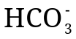) concentration (a[]) or the Base Excess (BE) for the evaluation of the metabolic component [1, 2]. Arterial acid-base values, however, are linearly related [1]. This means that if two of the three parameters are known, the third can be calculated. Thus, clinicians use three acid-base parameters to assess the acid-base status of a patient as if they were independent of each other, although only two of the three variables can change independently.
Although a strict linear relationship is not self-evident for pH, PaCO₂ and BE, an almost linear relationship is also present between these three variables. This was discovered during an earlier study [3] in which the distributions of large collections of pH, PaCO₂ and BE values were explored, using graphical software with capabilities of on-line three-dimensional rotation. During these explorations it was realised that, when plotting the combinations of the three variates as they occur in practice in three-dimensional space, the points are located on a surface with only a slight curvature.
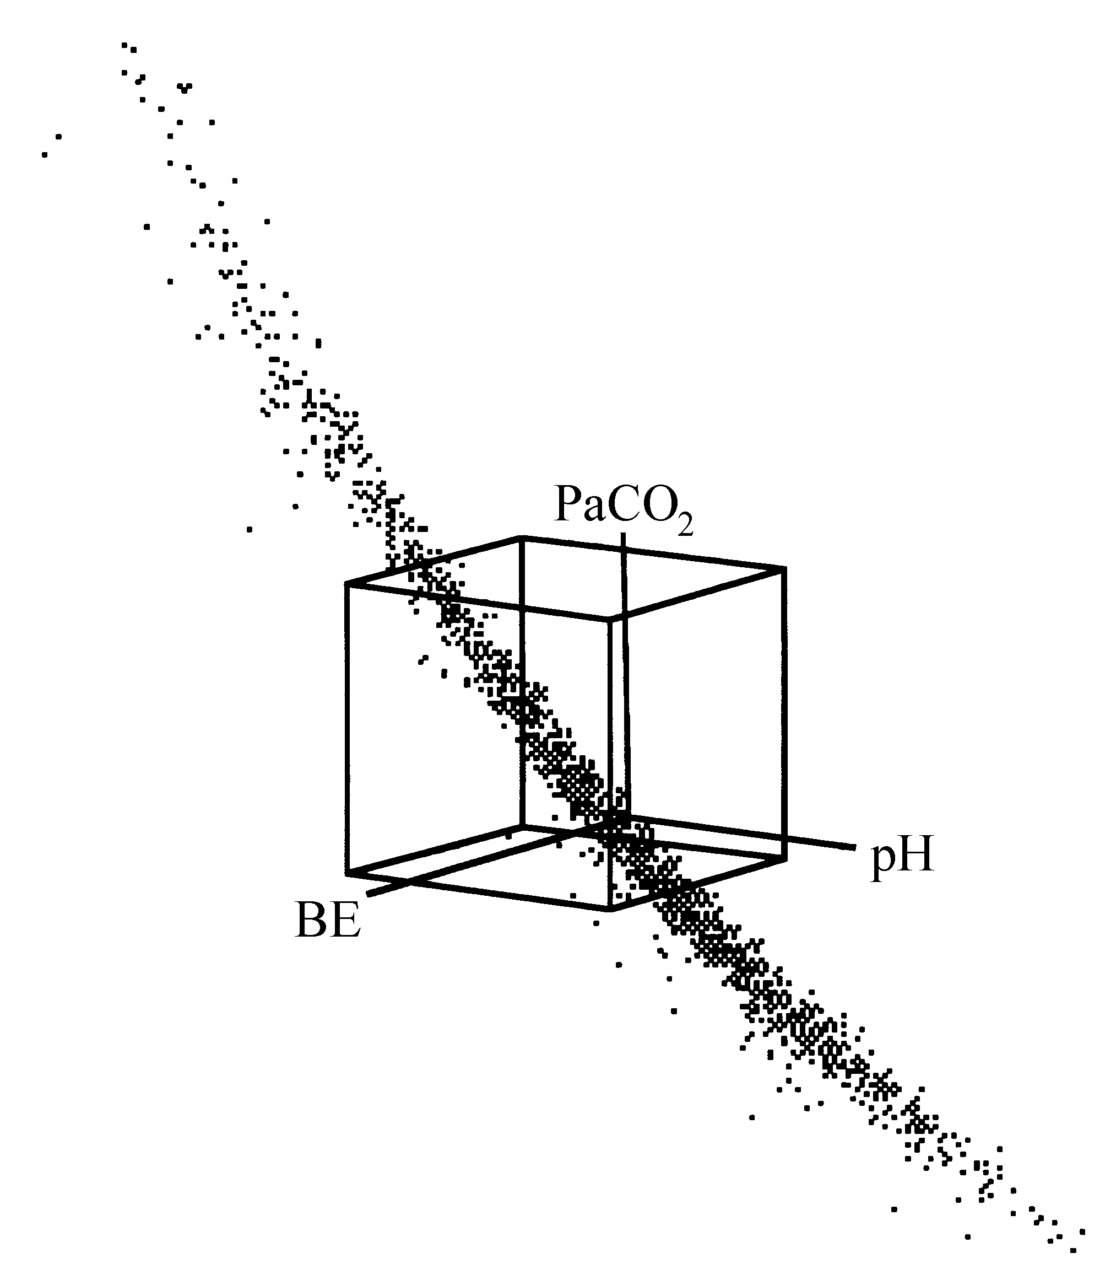
Figure 2–1. Three-dimensional view of rotated pH, PaCO₂ and BE values for the ELIbe data set. The cube represents the 95% reference volume as defined by the 95% univariate reference intervals of Table 2–1.
Figure 2–1 displays such a pH, PaCO₂ and BE distribution in three dimensions. The distribution is rotated in such a way that the curved plane of measurements can be easily viewed. The cube in the middle is the volume in three dimensions that represents the standard reference volume, as built from the three standard univariate 95% reference intervals for pH, PaCO₂ and BE of Table 2–1.
Having observed that the relationship between the arterial acid-base variables (both for combinations of pH, PaCO₂ and BE and pH, log PaCO₂ and log a[]) is an almost linear one, the goal is to arrive at a mathematical description of this relationship and to investigate its departure from linearity. The mathematical technique to be used for such an investigation is a principal component analysis (PCA). PCA is a multivariate statistical technique for the compression of large data matrices [4, 5]. In this chapter, the results of a PCA of several distributions of acid-base data, coming from various ICUs, are described.

Materials and methods
Table 2–1. Means (m) and standard deviations (s) as derived from the standard 95% reference intervals for the arterial acid-base variables. The standard deviations are calculated by assuming the 95% reference intervals to be 4 standard deviations wide.
 | 95 % reference interval | m | s
pH | 7.35 – 7.45 | 7.40 | 0.025
PaCO₂ (mmHg) | 35 – 45 | 40 | 2.5
PaCO₂ (kPa) | 4.7 – 6.0 | 5.33 | 0.325
BE (mmol/l) | -3 – 3 | 0 | 1.5
a[] (mmol/l) | 21 – 27 | 24 | 1.5
log PaCO₂ (mmHg) | log 35 – log 40 | log 40 | (log 35 – log 40) / 4
log PaCO₂ (kPa) | log 4.7 – log 6.0 | log 5.33 | (log 4.7 – log 6.0) / 4
log a[] | log 21 – log 27 | log 24 | (log 21 – log 27) / 4

Patient data
Six acid-base data sets from four different intensive care units were submitted to PCA. Data set AZRbe contains 1500 unselected combinations of pH, PaCO₂ and BE values from patients of the respiratory ICU of the Dijkzigt academic hospital, Rotterdam, The Netherlands. The term unselected means that no specific selection criteria were applied. In fact, all data sets are constructed by sampling the acid-base data as consecutively measured in the respective clinical laboratories. Data set OLVGbe contains 1500 unselected combinations of pH, PaCO₂ and BE values from patients of the general ICU of the OLVG hospital, Amsterdam, The Netherlands. Data set OLVGab comprises the 1500 combinations of pH, log PaCO₂ and log a[] values from the same patients as the OLVGbe data set. Data set SKZbe contains 1500 combinations of pH, PaCO₂ and BE values from patients of the neonatal ICU of the Sophia Children’s hospital, Rotterdam, The Netherlands. The data set is composed of equal numbers of data in three age groups: new-borns younger than five days, infants between five days and one month of age, and infants aged between one month and one year. Data set ELIbe contains 1500 unselected combinations of pH, PaCO₂ and BE values from the general ICU of the St. Elisabeth hospital, Tilburg, The Netherlands. Data set ELIab comprises the 1500 combinations of pH, log PaCO₂ and log a[] from the same patients as the ELIbe data set.

Standardisation
Prior to the principal component analysis of an acid-base data set, each variable in the data set was standardised with fixed means and standard deviations according to:
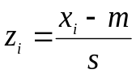, i = 1,...,N (2–1)
where m and s are, respectively, the mean and standard deviation for the respective acid-base variables as presented in Table 2–1, while N is the total number of cases in the data set. The z_{i}-values are therefore the deviations from the mean m, measured in units of the corresponding standard deviation s.

Principal component analysis
The standardised data sets were then subjected to PCA. PCA is a mathematical transformation that enables the reduction of the number of variables in a multivariate data set whilst preserving as much of the original information as possible [4, 5]. Assuming a multivariate data set with p variables (x₁, x₂,..., x_{p}), PCA finds a new set of derived variables (z₁, z₂,...,z_{p}) that are linear functions of x₁, x₂,..., x_{p} with the following properties:
z₁ has maximum possible variance among all possible linear functions of x₁, x₂,..., x_{p}.
z_{k} has maximum possible variance among all possible linear functions of x₁, x₂,...,x_{p}, subject to z_{k} being uncorrelated with z₁, z₂,...z_{k-1}, for 2 ≤ k ≤ p [4].
The derived variables z₁, z₂,...,z_{p} are called the principal components or PCs.
In linear algebraic terms, PCs are determined with an eigenvalue transformation of the variance-covariance matrix as derived from the multivariate data set. For a set of N vectors x_{i} (i = 1,..., N) in a p-dimensional data set, the variance-covariance matrix V is defined as:
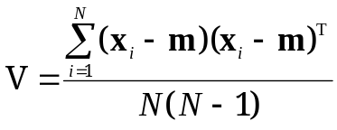 (2–2)
where m is the vector of the mean of the set x_{i} (i = 1,..., N) and the superscript t indicates transposition of a vector, in the convention that an untransposed vector is a column vector. The eigenvalue transformation yields a transformation matrix U, which transforms the original vectors x into vectors y, according to y = U x, such that the variance-covariance matrix W = UVU^{T} of the transformed vectors y is a diagonal matrix. If U is constrained to be a unitary matrix, the component variances of the transformed vectors y appear as eigenvalues (λ) in the analysis and are found as the diagonal elements of W.
Since the eigenvalue transformation diagonalises the variance-covariance matrix, the total variance in the set of original vectors x is decomposed into p orthogonal directions. Thus, for a set of p-dimensional vectors x for which it is observed that most of the variance is confined to a subspace of dimension l < p, it is expected that the components 1 through l of the transformed vectors y contain most of the useful information. The components l +1 through p have only a small variance, and thus convey (almost) no information. In the present situation, p = 3 and due to the (almost) linear relationships between the variables in the standardised data sets, it is expected that l = 2.

Results
Table 2–2 presents the results of the principal component analysis of each data set. The eigenvalues λ are shown for each of the three principal components (hereafter referred to as PC1, PC2 and PC3). The eigenvalues λ explain the contribution of each of the principal component to the total variance in the data set prior to PCA. For instance, in the AZRbe data set, PC1, PC2 and PC3 explain 62.37%, 36.91% and 0.71% of the total variance in the initial data set, respectively. From Table 2–2 it can be concluded that for each data set, the percentage of variance explained by the third principal component (PC3) is only small compared to the variance explained by the first two principal components (PC1 and PC2) together. The explained variance by PC1 and PC2 for each data set is more than 99%. The data sets OLVGab and ELIab show the smallest explained variance by PC3; 0.03% and 0.09%, respectively. This is not surprising since these data sets consist of pH, log PaCO₂ and log a[] values and these variables are linearly related according to the Henderson-Hasselbalch equation (see Chapter Error: Reference source not found) [1].
Table 2–2. Eigenvalues λ and contributions to the total variance in the initial data set (in brackets) for each principal component.
 | PC1 | PC2 | PC3
AZRbe | 20.54 (62.37%) | 12.16 (36.91%) | 0.235 (0.71%)
OLVGbe | 26.04 (69.70%) | 11.22 (30.03%) | 0.101 (0.27%)
OLVGab | 25.52 (74.30%) | 8.82 (25.67%) | 0.009 (0.03%)
SKZbe | 21.09 (78.01%) | 5.87 (21.72%) | 0.072 (0.27%)
ELIbe | 23.62 (64.55%) | 12.83 (35.07%) | 0.137 (0.37%)
ELIab | 20.36 (58.91%) | 14.17 (41.00%) | 0.032 (0.09%)

For each data set, a matrix U can be built from the three separate normalised eigenvectors ε, which are used to calculate the associated principal component values from a combination of standardised original acid-base values. Table 2–3 shows the normalised eigenvectors ε of each principal component for all data sets. With the matrices U, new trivariate distributions of principal component values were calculated from the original standardised acid-base data sets.
Table 2–3. Normalised eigenvectors ε of each principal component as obtained after PCA. The eigenvectors for PC1, PC2 and PC3 are columns 1, 2 and 3, respectively of the eigenmatrix matrix U. The eigenmatrix U will be the input of calculations to be presented in the next chapters.
 | PC1 | PC2 | PC3
AZRbe | (0.297, -0.885, -0.358) | (0.709, -0.046, 0.703) | (0.639, 0.463, -0.614)
OLVGbe | (-0.039, -0.777, -0.628) | (0.742, -0.444, 0.503) | (0.669, 0.446, -0.594)
OLVGab | (0.044, 0.686, 0.727) | (-0.839, 0.420, -0.346) | (0.542, 0.594, -0.594)
SKZbe | (0.635, -0.757, 0.153) | (0.425, 0.508, 0.749) | (0.645, 0.411, -0.649)
ELIbe | (0.732, -0.184, 0.656) | (-0.184, 0.874, 0.450) | (0.656, 0.450, -0.605)
ELIab | (0.734, -0.012, 0.679) | (-0.391, 0.811, 0.436) | (0.556, 0.585, -0.590)

Table 2–4 presents the characteristics of the resulting principal component value distributions. For each data set, the standard deviation of the PC3 distribution is small compared to the standard deviations of the PC1 and PC2 distributions. Data set OLVGab and ELIab have the smallest standard deviations for the third principal component value distribution: 0.097 and 0.178, respectively. This is in accordance with the results presented in Table 2–2.
Table 2–4. Characteristics (m is mean and s is the standard deviation) of the principal component value distributions.
 | PC1 |  | PC2 |  | PC3
 | m | s | m | s | m | s
AZRbe | 1.282 | 4.532 | 0.695 | 3.487 | 0.177 | 0.485
OLVGbe | -0.773 | 5.103 | -0.315 | 3.349 | -0.215 | 0.317
OLVGab | 0.357 | 5.052 | 0.250 | 2.969 | -0.282 | 0.097
SKZbe | -3.358 | 4.593 | -2.676 | 2.423 | -0.109 | 0.268
ELIbe | -1.025 | 4.860 | 0.062 | 3.582 | -0.005 | 0.370
ELIab | -1.008 | 4.513 | -0.038 | 3.765 | -0.071 | 0.178

Since for each data set the amount of explained variance is more than 99% when only PC1 and PC2 are considered, there is no significant loss of information when the acid-base values are projected onto the plane spanned by PC1 and PC2. Hence, any quantitative analysis based on PC1 and PC2 addresses the complete acid-base status. In Figure 2–2, scatterplots of PC2 versus PC1 are shown for all data sets.
Since the plane of measurements in case of a pH, PaCO₂ and BE data set is slightly curved (see Figure 2–1), it is interesting to investigate the effect of the curvature on the distribution of PC3 values. Therefore, the PC3 distribution characteristics of two data sets were investigated. This was done by constructing box-whisker plots of groups of PC3 values that are increasingly further away from the bivariate PC1-PC2 mean. As a cut-off point, a distance of 1 standard deviation score was chosen with a maximum of 10, yielding 11 groups of data. A box-whisker plot provides a graphical representation of the distribution of values in a given data set. The outer top and bottom horizontal lines of the box-whisker plots indicate the 95th and 5th percentiles of a distribution, respectively. The top and bottom horizontal lines enclosing the box denote the 75th and the 25th percentile, respectively. The horizontal line inside the box denotes the median.
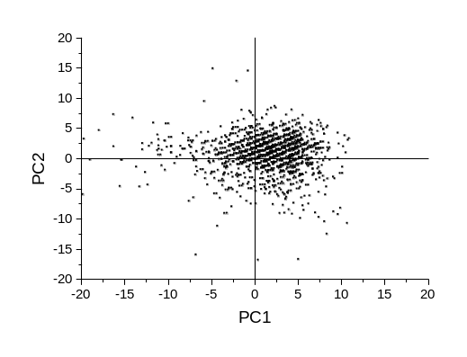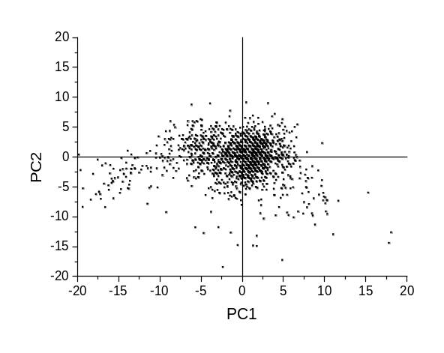
AZRbe OLVGbe
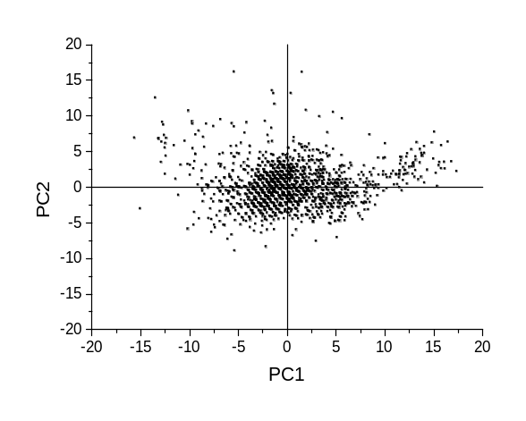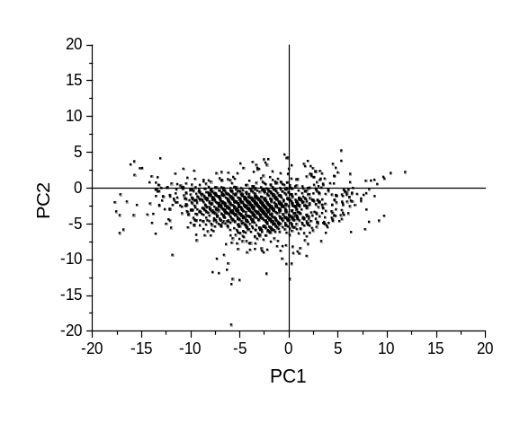
OLVGab SKZbe
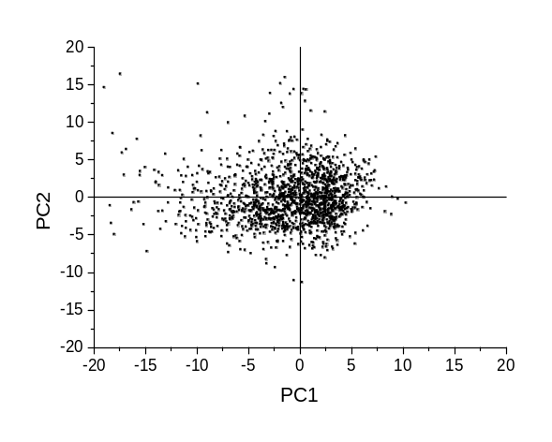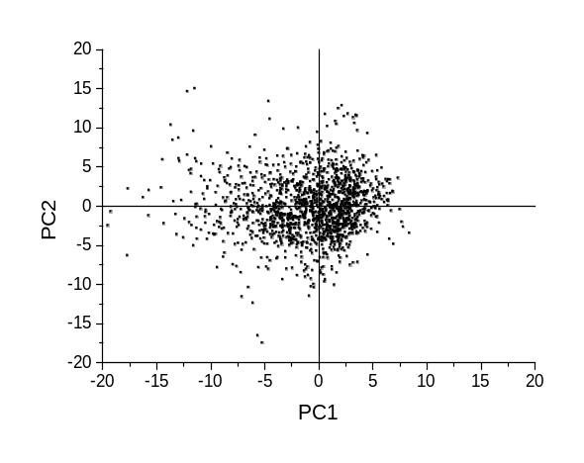
ELIbe ELIab
Figure 2–2. Projections of the 1500 acid-base observations on the plane spanned by the first two principal components (PC1 and PC2).
Figure 2–3 shows the box-whisker plots for the OLVGbe data set. In Figure 2–4 the box-whisker plots are shown for the OLVGab data set. Comparing both figures, it is apparent that with increasing distance from the mean in the plane spanned by the first two principal components PC1 and PC2, the variance in the PC3 distribution increases for data set OLVGbe, while the variance in the PC3 distribution of data set OLVGab remains the same for all distance strata. This variance explains the slight curvature of a PCA transformed pH, PaCO₂ and BE data set which is absent in a PCA transformed pH, log PaCO2 and log a[] data set.
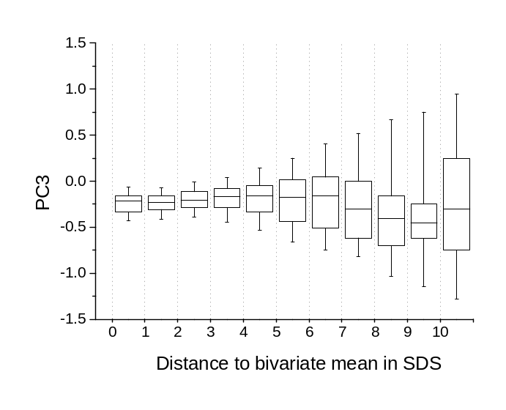
Figure 2–3. Box-whisker plots as a function of the distance from the mean in the PC1-PC2 plane for data set OLVGbe. SDS stands for ‘standard deviation score’.
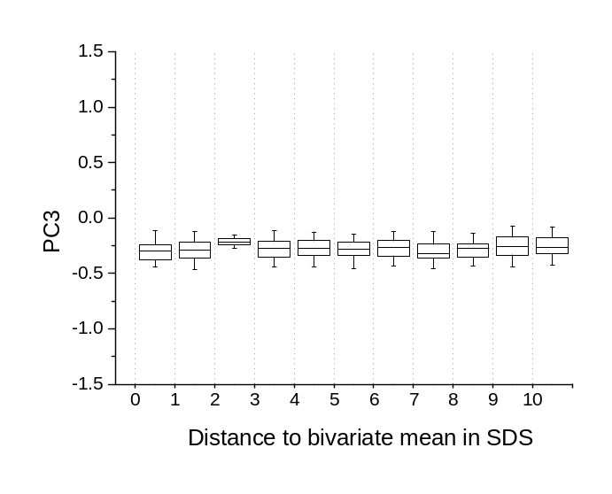
Figure 2–4. Box-whisker plots as a function of the distance from the mean in the PC1-PC2 plane for data set OLVGab.
Figure 2–5 presents a histogram of the 1500 calculated PC3 values of the transformed OLVGab distribution. The straight line in the normal probability plot in the upper part of Figure 2–5 indicates that the 1500 PC3 values are normally distributed. This was confirmed with a Kolmogorov-Smirnov distribution fit test (D_{max} of 0.03 with a p-value of 0.118). Since these PC3 values are normally distributed, a parametric 95% reference interval may be derived from this distribution as m ± 2s, resulting in a reference range of -0.472 to
-0.092. The calculated PC3 value of a pH, log PaCO₂, log a[] combination from an IC patient of the OLVG hospital, transformed with the corresponding eigenvectors of Table 2–3, will have a probability of 95% of being located within this interval. A similar analysis, however, on the 1500 PC3 values of the transformed data set ELIab showed a bimodal distribution of PC3 values (Figure 2–6). Consequently, the distribution was found to be significantly deviating from a normal distribution (D_{max} of 0.263 with a p-value < 0.01).

Discussion
In 1979, Madias et al. [6] already noted that, when evaluating an acid-base status, it is illogical and fundamentally wrong to use pH, PaCO₂ as well as a[], while only two of these three variables are free to change independently. He proposed to evaluate acid-base disorders with only two of the three basic acid-base variables. This means, however, that clinicians are deprived of one of the three variables on which the interpretation of the acid-base status is traditionally based.
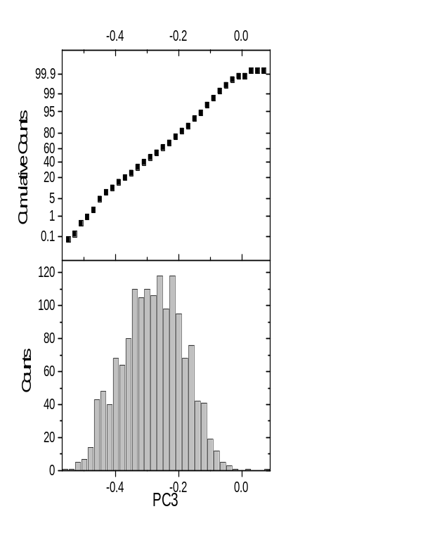
Figure 2–5. Histogram and normal probability plot of the 1500 third principal component values (PC3) of the OLVGab data set.
In this chapter, a solution is proposed that allows a quantitative analysis of all three basic acid-base variables while being faithful to the interdependence between them. A multivariate statistical technique called principal component analysis (PCA) was used to reduce the dimensionality of large trivariate distributions of acid-base variables. Results show that the acid-base status can be faithfully represented in a principal component subspace defined by the principal components PC1 and PC2, without significant loss of information. The distortion, measured as a percentage of variance not represented, is shown to be less than 0.7% for all the data sets investigated. The (small) percentage of explained variance by PC3 in data sets of pH, log PaCO₂ and log a[] (data sets OLVGab and ELIab) may be attributed to rounding effects and analytical imprecision. For the other data sets, consisting of pH, PaCO₂ and BE values, the curvature of the plane of measurements is an extra source of variance resulting in larger percentages of variance explained by PC3. However, this source of variance is only minor and for each data set it is therefore justified that quantitative analyses of acid-base disorders be based on PC1 and PC2 values after a PCA transformation, rather than on the original acid-base values. Furthermore, projection of the original points onto the PC1-PC2 subspace is (almost) distortionless. In Chapter Error: Reference source not found, this characteristic is used to define a sound way to graphically represent all three acid-base variables in a single two-dimensional representation.
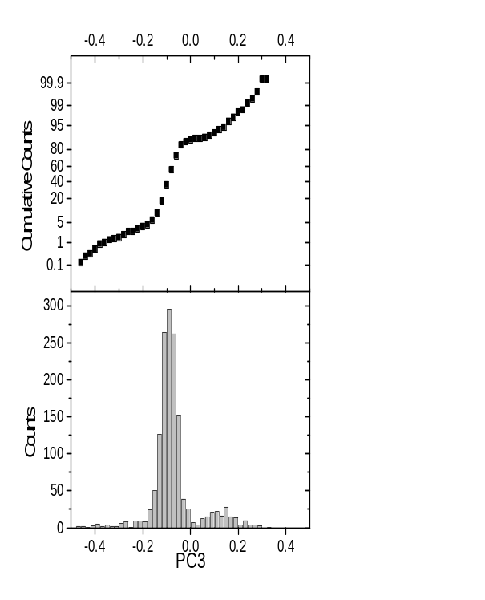
Figure 2–6. Histogram and normal probability plot of the 1500 third principal component values (PC3) of the ELIab data set.
The minor variance in PC3 may also serve as a plausibility check for acid-base laboratory values; each transformed combination of pH, PaCO₂ and a[]/BE must lead to a small PC3 value. For a pH, log PaCO₂ and log a[] data set, PC3 must be within the 95% reference interval for PC3 as obtained from the PC3 values after PCA of an acid-base data set. For instance, the 95% reference interval for PC3 of the OLVGab data set was found to be -0.472 to 0.092. If a transformed combination of acid-base measurements is not within the interval, then it may be concluded that this specific combination of pH, PaCO₂ and a[] is not valid. Note that the interval is not equally centred around zero. From the definition of PCA one would expect that, when calculated means and standard deviations are used, the mean value for all principal component values would be zero. However, for the standardisation procedure the fixed means and standard deviations of Table 2–1 were used, leading to the observation that the mean values of the principal components are different from 0 for the various data sets, since they have different means and variances for the original acid-base values.
Checking whether the PC3 value of a transformed acid-base observation is within the 95% reference interval is only possible for data sets of pH, log PaCO₂ and log a[], since the variance in PC3 is independent of the distance of an observation to the PC1-PC2 bivariate mean (see Figure 2–6). Observations in a data set of pH, PaCO₂ and BE are located on a slightly curved plane of measurements, resulting in the effect that with increasing distances from the PC1-PC2 bivariate mean, the variance in PC3 increases (see Figure 2–3). To check the plausibility of a transformed pH, PaCO₂ and BE combination one could either use the variance in PC3 as found for data with distances larger than or equal to 10 standard deviations scores (≥ 10), or use the variance in PC3 in the associated distance group.
One could argue that the relationship between the acid-base variables could be described by studying the formula used in acid-base analysers to calculate a[] or BE from measured pH, PaCO₂ and haemoglobin. The advantage of the approach presented in this chapter, however, is that no prior knowledge is needed about the formula with which the a[] or the BE are calculated. The method, therefore, adapts itself to the instruments used.

Acknowledgements
I am indebted to dr. R.N.M. Weijers and dr. D. Zandstra for making the data sets OLVGbe and OLVGab available. Dr. B. van der Berg and dr. R.W. Wulkan contributed similar material: the data sets AZRbe and SKZbe, respectively. Finally, dr. J.E. van Puyenbroek and dr. B. Speelberg provided the data sets ELIbe and ELIab.

References
1. Rose BD. Clinical Physiology of Acid-Base and Electrolyte Disorders. 4th Edition, New York: McGraw-Hill, Inc., 1994; 853.
2. Astrup P, Jörgensen K, Siggaard-Andersen O, et al. The acid-base metabolism, a new approach. Lancet 1960;1035-1039.
3. Gelsema ES, Leijnse B, Wulkan RW. A multi-dimensional analysis of three chemical quantities in the blood. Med Inform 1991; 16:43-54.
4. Jolliffe IT, Morgan BJT. Principal component analysis and exploratory factor analysis. Stat Meth Med Res 1992; 1:69-95.
5. Jolliffe IT. Principal Component Analysis. New York: Springer-Verlag, 1986, Springer Series in Statistics; vol 12.
6. Madias NE, Adroqué HJ, Horowitz GL, et al. A redefinition of normal acid-base equilibrium in man: Carbon dioxide tension as a key determinant of normal plasma bicarbonate concentration. Kidney Int 1979; 16:612-618.

